THE BAHA CUP
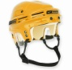 1994 – CHARLIE | 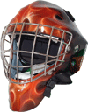 2008 - TRUNG
1995 – CHARLIE | 2009 – CHARLIE
1996 – CHARLIE | 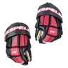 2010 – JASON T.
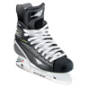1997 – ADAM | 2011 - TRUNG
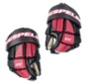 1998 – GARRETT | 2012 – TRUNG
1999 – GARRETT | 2013 – TRUNG
2000 – CHARLIE | 2014 – TRUNG
2001 – CHARLIE | 2015 - ?
2002 – CHARLIE
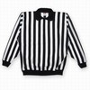 2003 – N/A
2004 – NHL LOCK-OUT
2005 – TRUNG | Tally: 19 years!
2006 – CHARLIE | Charlie – 8  Trung - 6
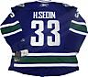 2007 – MATT | Matt – 1  Other – 4

